THE UGANDA INTERGOVERNMENTAL FISCAL TRANSFERS (UGIFT)

FIELD ASSET VERIFICATION REPORT OF
LABONGO SEED SECONDARY SCHOOL AND LABONGO AMIDA SEED SECONDARY SCHOOL

Date: 28th / 08/ 2026
KITGUM DISTRICT LOCAL GOVERNMENT
DEO: Helped in informing the head teacher at the school we were supposed to visit

LABONGO SEED SEC SCHOOL
The Head teacher said he was new in the institution and that most of the items were delivered not in his presence.
He took us through the facility and helped us during the verification process.

FINDINGS
SCHOOL BUILDINGS
- 6 Class rooms
- 2 laboratories
- 1 core multipurpose hall
- 1 administration block with offices and staff room
- 6 staff house units
- 6 staff kitchen units
- 3 school toilets (2 for students and 1 for staff)
FURNITURE
- 266 office Chairs
- 11 office tables
- 4 staff room tables
- 127 tables for laboratory and Computer Lab
- 24 Science Lab Tables
- 84 Lab Stools
- 2 long Waiting Benches
- 19 Book Shelves
- 120 Desks i.e. 20 desks per class
ICT DEPARTMENT
- 20 Desktop monitors (DELL)
- 20 CPU’s (DELL)
- 20 Computer Mouse and 20 Key boards
- 1 set of CCTV Camera
- 1 Air Conditioner
- 1 Server Processer
- 1 Network Switch support
- 1 printer
- 20 Interrupted power Supply
- 2 Wireless Routers(2D-Link)
CHALLENGES
- Water supply Challenge as the school only depends on rain harvested water as a source
- Limited Power Supply as the school only uses a generator.
- Insecurity, the school has no Fence
RECOMMENDATIONS
- Build a fence for the School
- Provide a borehole as a source of water
- Provide Hydro Electric Power.
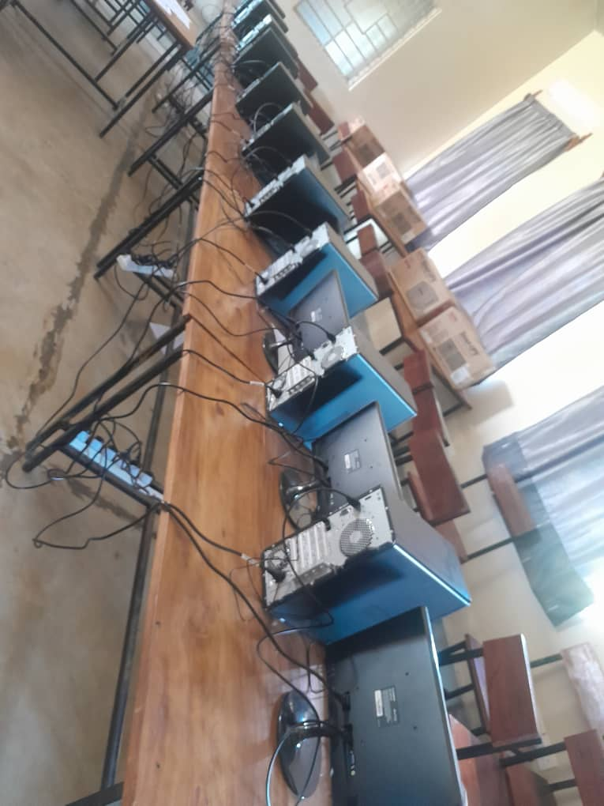
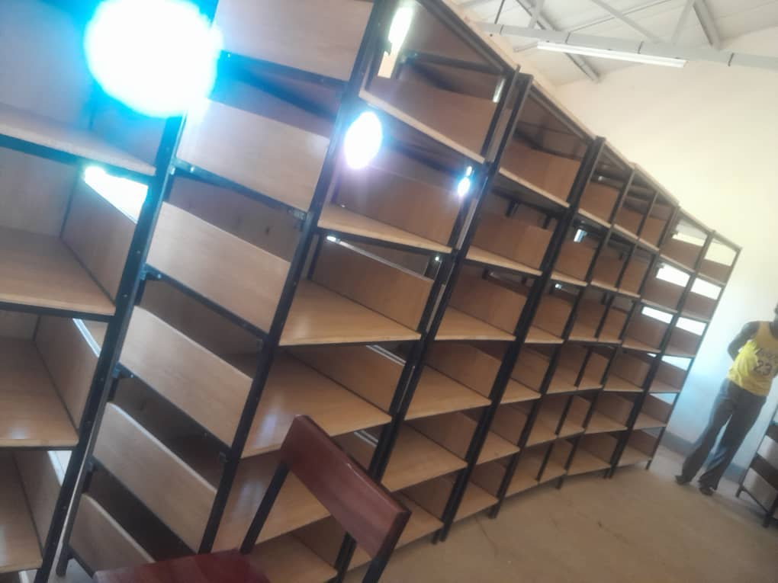
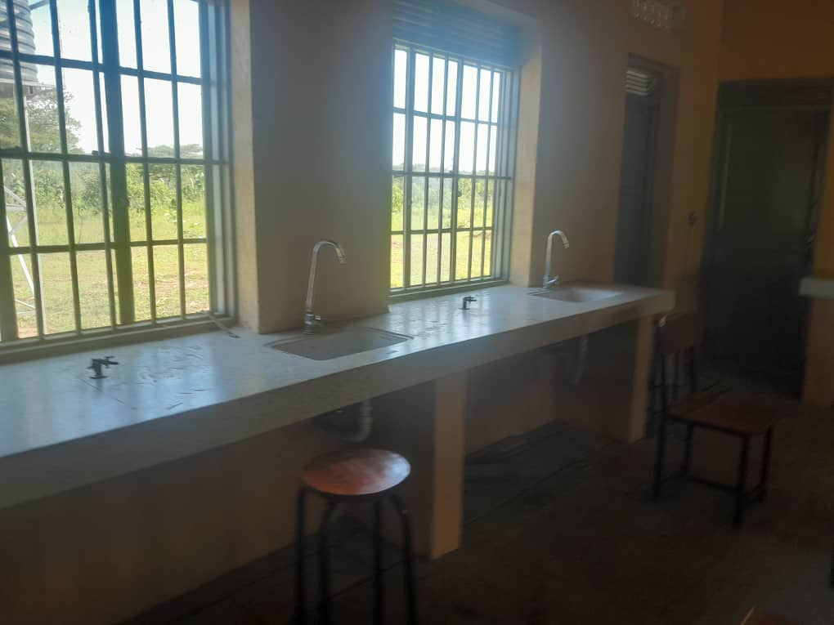
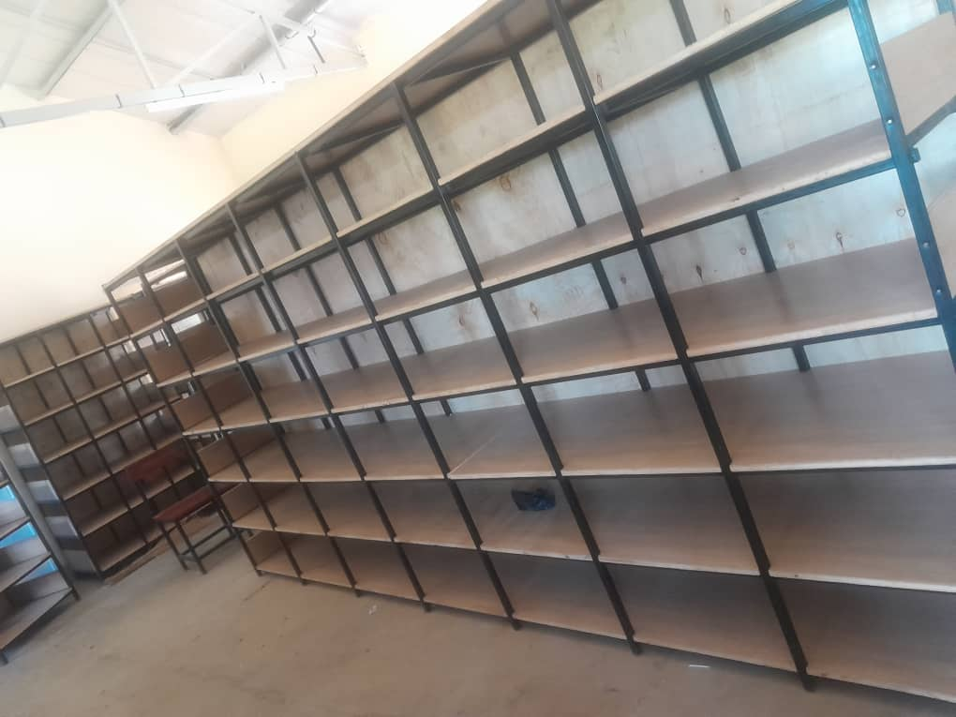
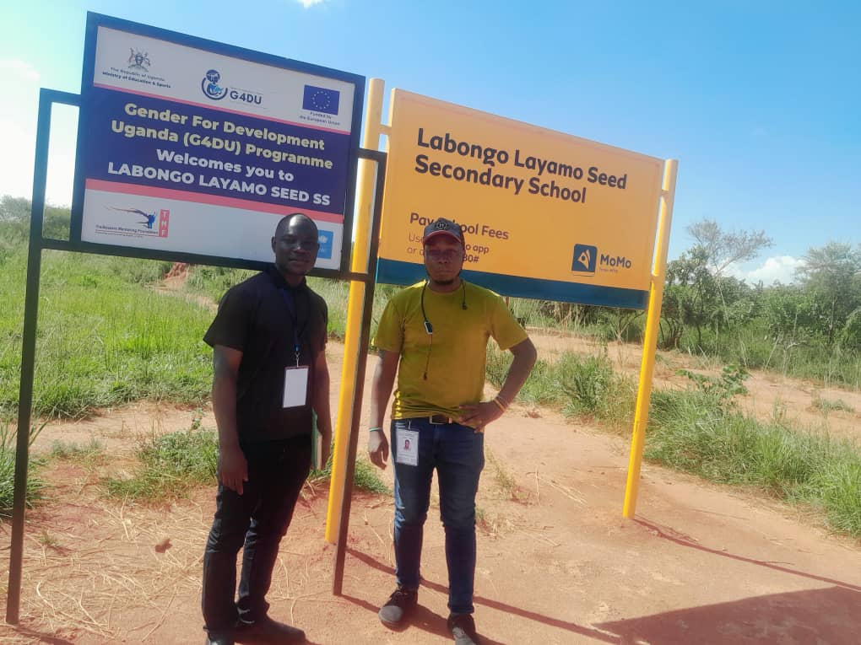
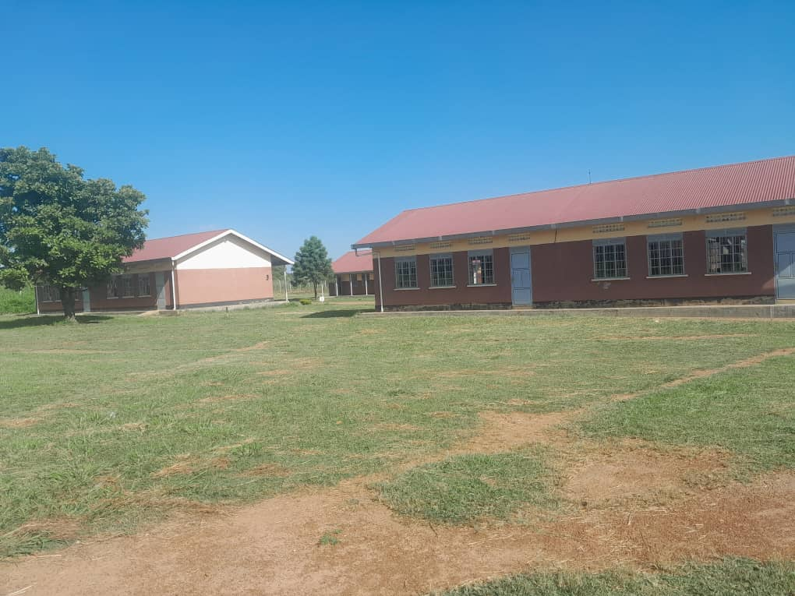
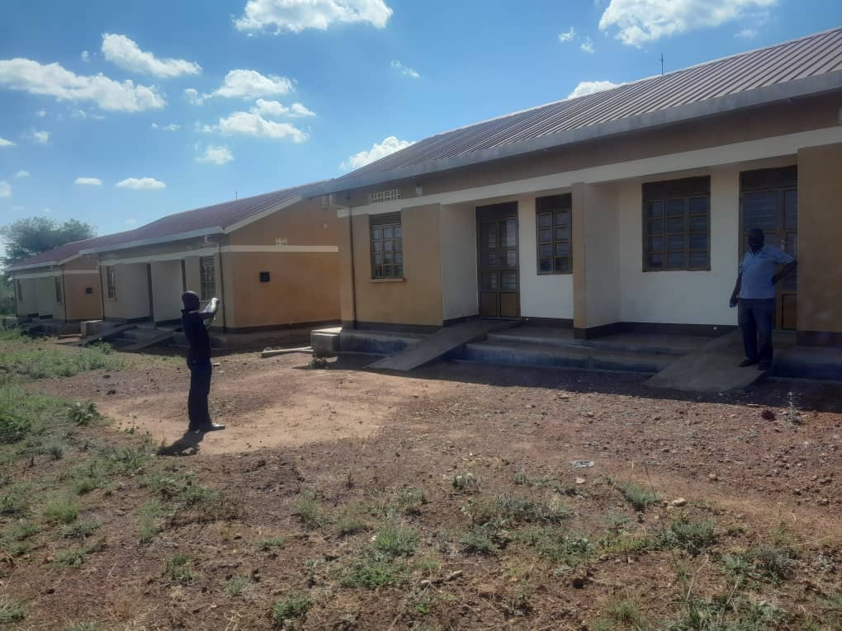
IMAGES FROM SCHOOL
LABONGO AMIDA SEC SCHOOL
The head master at this school was not around, so he allocated to us the director of studies who took us through the facility.
Most of the newly buildings were already worn out, this could be due to the incompetence of the engineers who did the construction.
FINDINGS
SCHOOL BUILDINGS
- 3 Blocks with 6 classrooms
- 2 Laboratories (Science)
- 1 Multi – purpose building (3 classes)
- 6 Staff units and 6 kitchen units
- 4 Water Tanks
- 1 Gas Cylinder
- 1 Football Pitch
- Fence (Wire mesh)
- 5 toilets
FURNITURE
- 126 Desks (21 Per Class) and 20 Broken
- 82 Lab tables
- 192 Lab Stools
- 5 office tables
- 12 office chairs (1 Broken)
- 260 Class room Chairs (10 broken)
ICT DEPARTMENT
- 15 Computer Sets (1 Broken)
- 1 Air Conditions
- 20 interrupted Power Supply

CHALLENGES
- The school has no power Source and this is the reason as to why some of the supplied equipment’s like AC, Cameras, Printers are not yet functional (in use)
- Limited water Supply
- No Kitchen
RECOMMENDATIONS
- Provide Power (HEP/Solar System)
- Provide a Water Supply (A borehole)
- Build a Kitchen
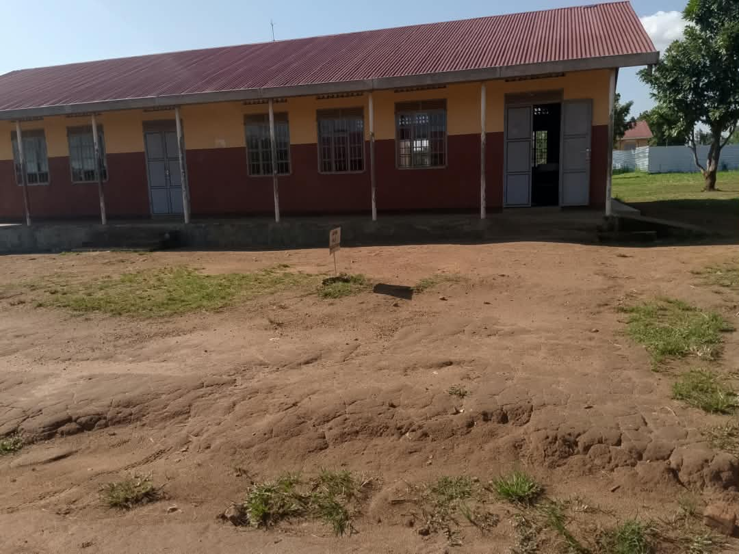
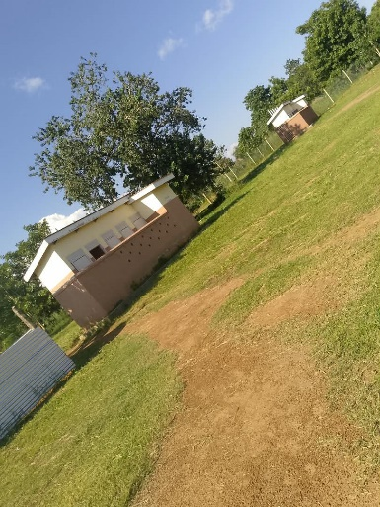
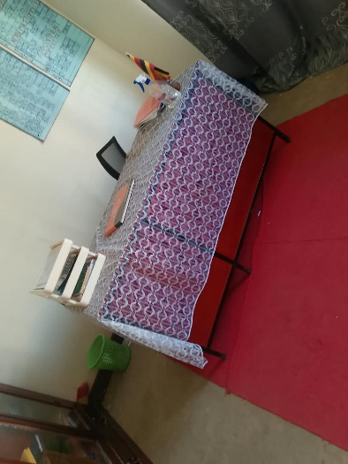
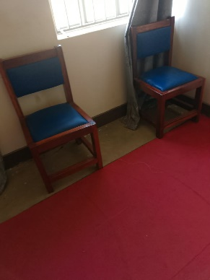
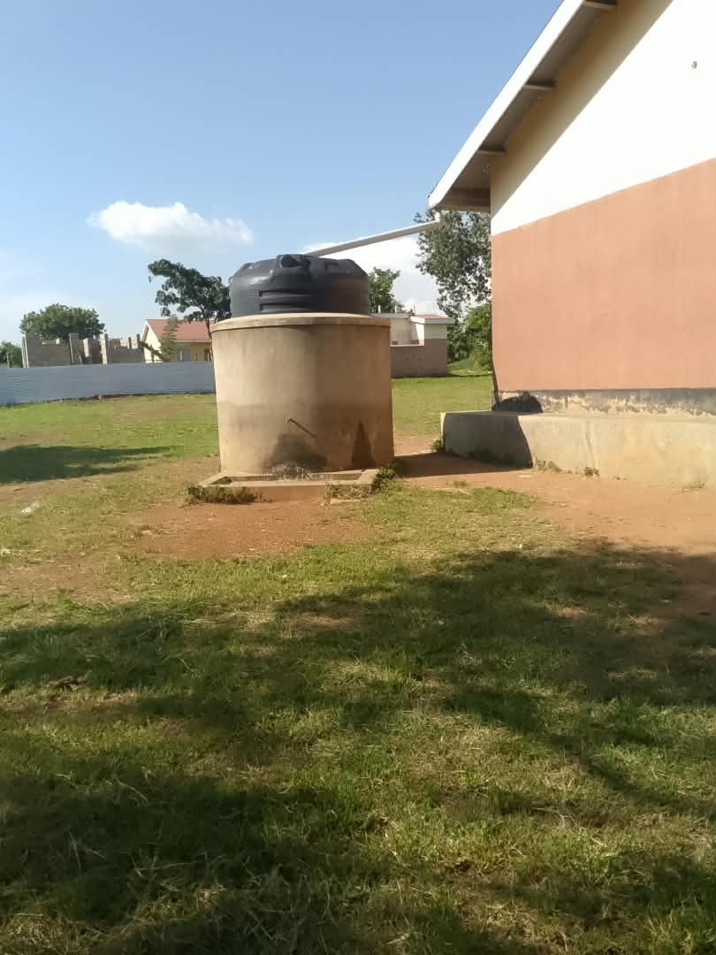
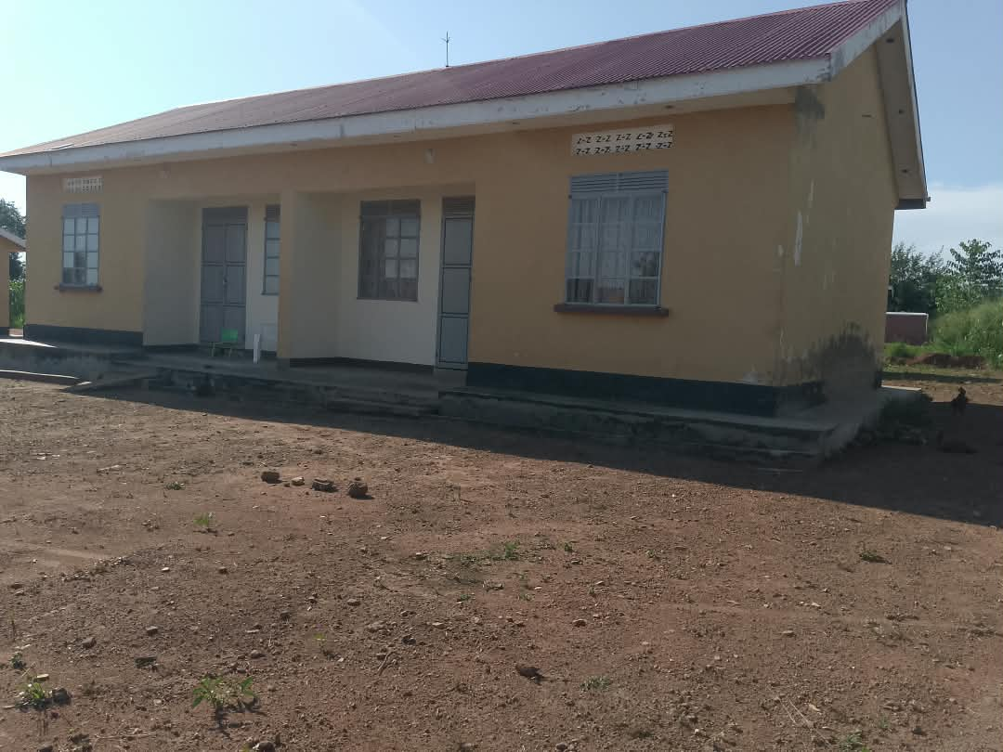
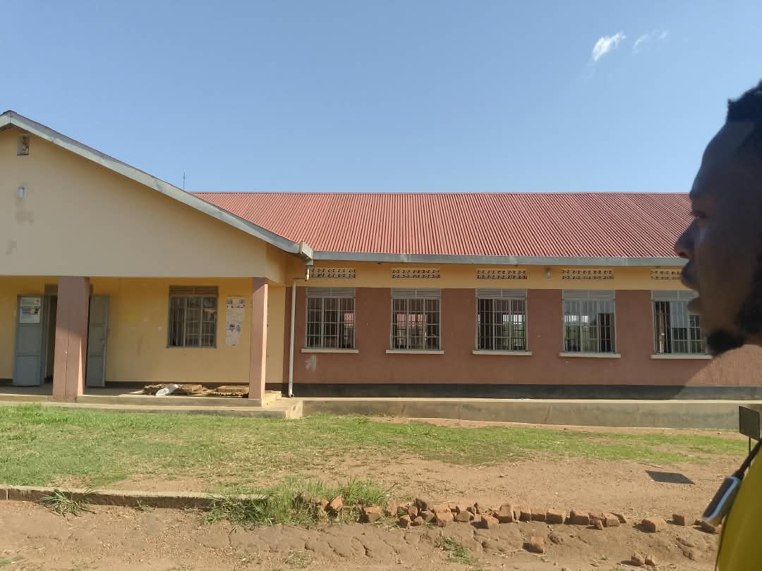
IMAGES FROM THE SCHOOL
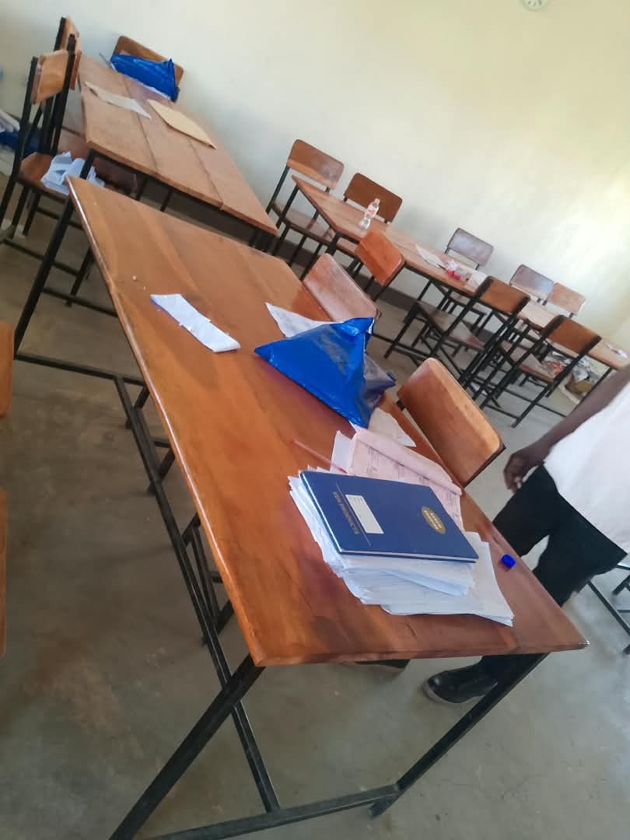
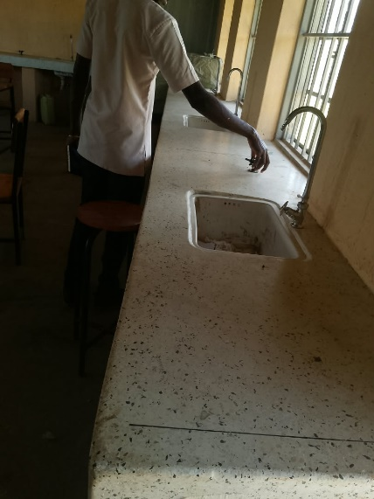
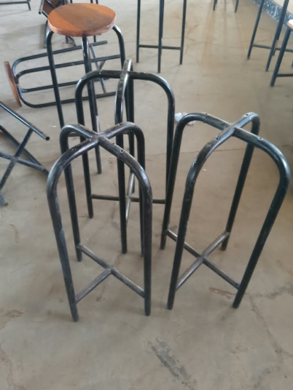
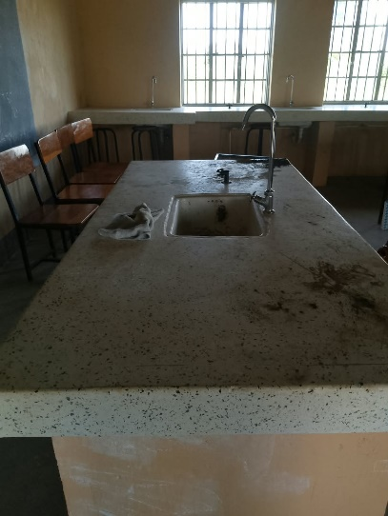
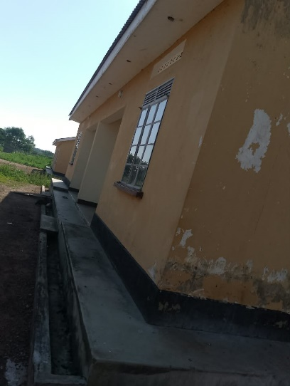
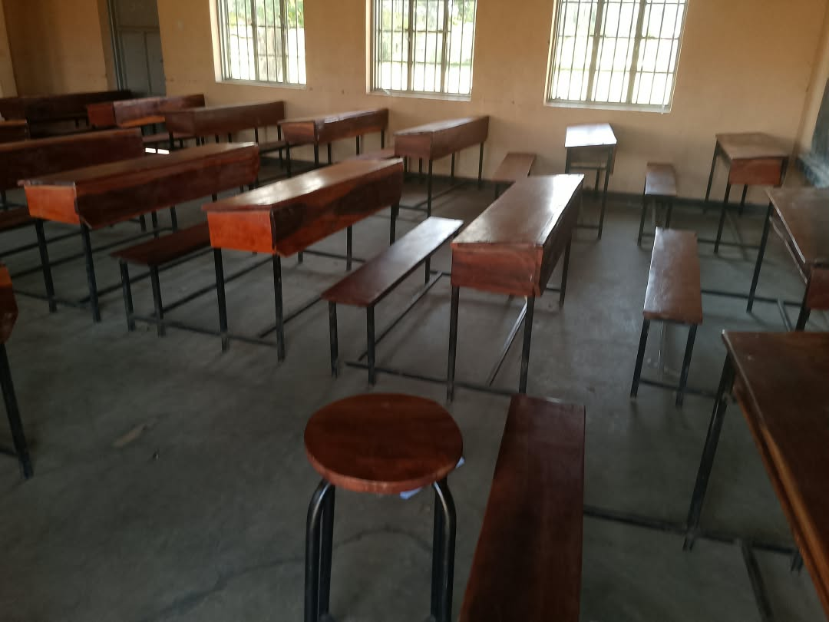
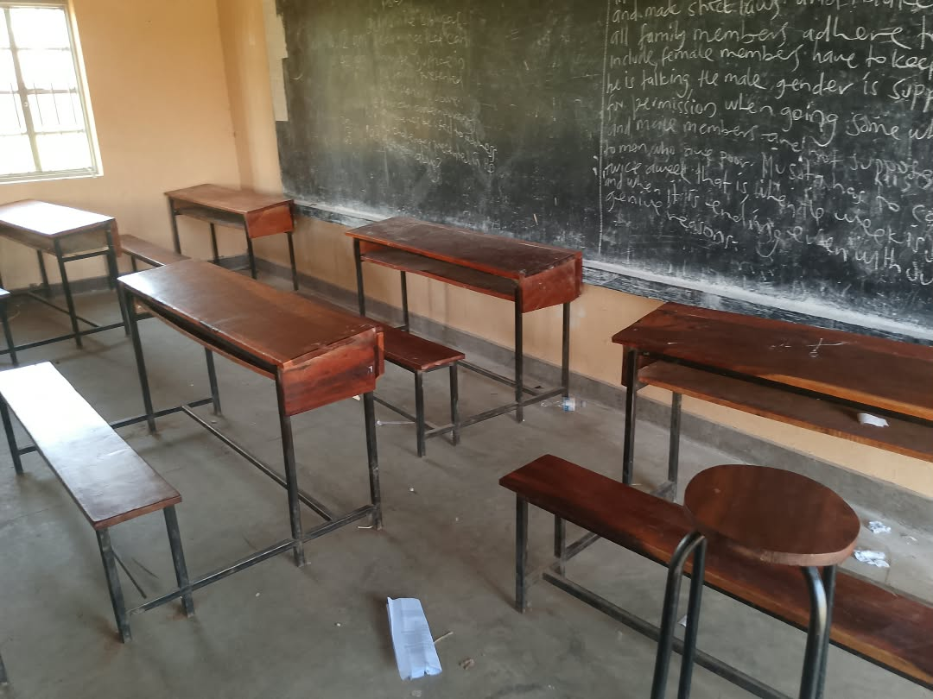
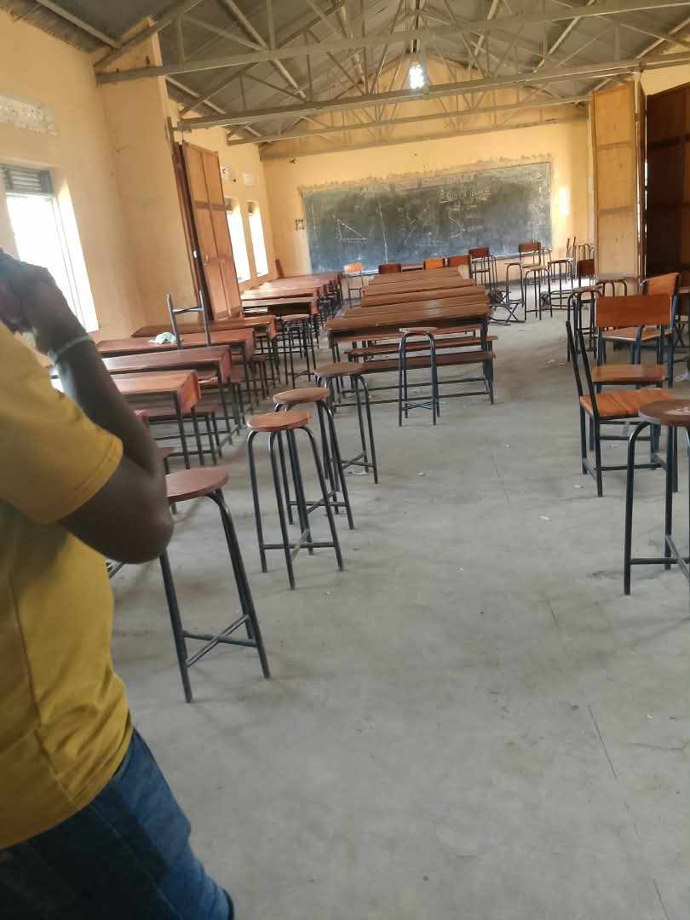
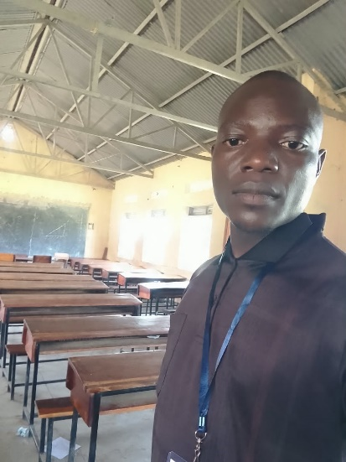
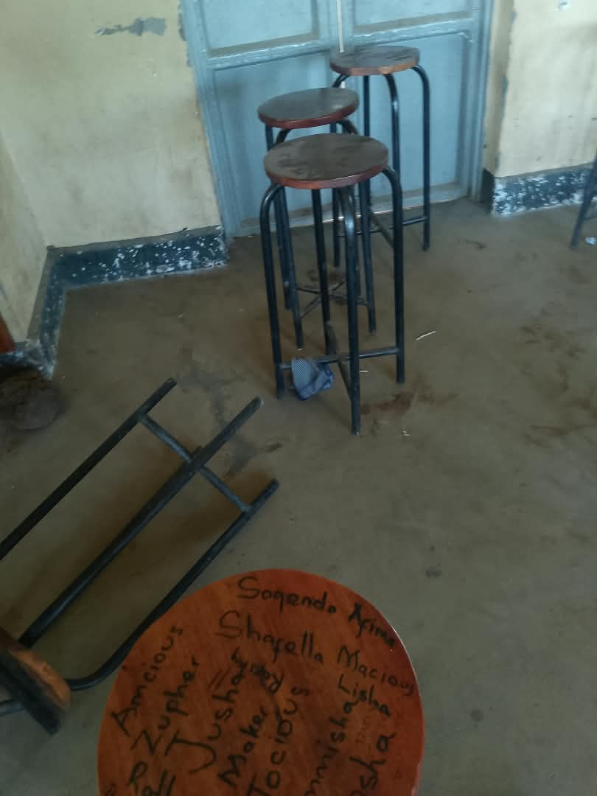
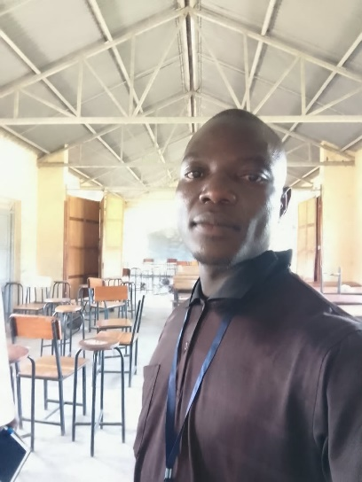

Report By:
Akwankwatsa Edwin
Tel: 0702527069
Email: piaedie@gmail.com

